Here is a complete, professional Project Documentation draft tailored for you. You can export this as a PDF or print it for your college records.

PROJECT DOCUMENTATION
Project Title: SSMIET Admission Portal
Version: 1.0.0

Developed By:
Veeramanikandan G.
2nd Year, B.Tech. Computer Science and Business Systems (CSBS)
SSM Institute of Engineering and Technology (SSMIET)

1. Executive Summary
The SSMIET Admission Portal is a robust, full-stack web application designed to digitize and streamline the college admission process. By transitioning from traditional paper-based workflows to a digital-first approach, the portal enhances operational efficiency, reduces manual data entry errors, and provides immediate, transparent communication to applicants. The system features real-time form validation, automated PDF application generation, and a secure, dual-channel email notification system for both students and administration.

2. Project Moto & Objectives
2.1. Moto
"Simplifying Access to Education through Digital Innovation."
2.2. Primary Objectives
- Automation: To eliminate manual processing of physical admission forms.
- Accessibility: To allow students to apply from anywhere, at any time.
- Transparency: To provide applicants with immediate proof of submission (Digital Receipt).
- Efficiency: To provide the administration with structured, digital records of every applicant instantly.

3. System Architecture
The project follows a Decoupled Client-Server Architecture, ensuring scalability and maintainability.
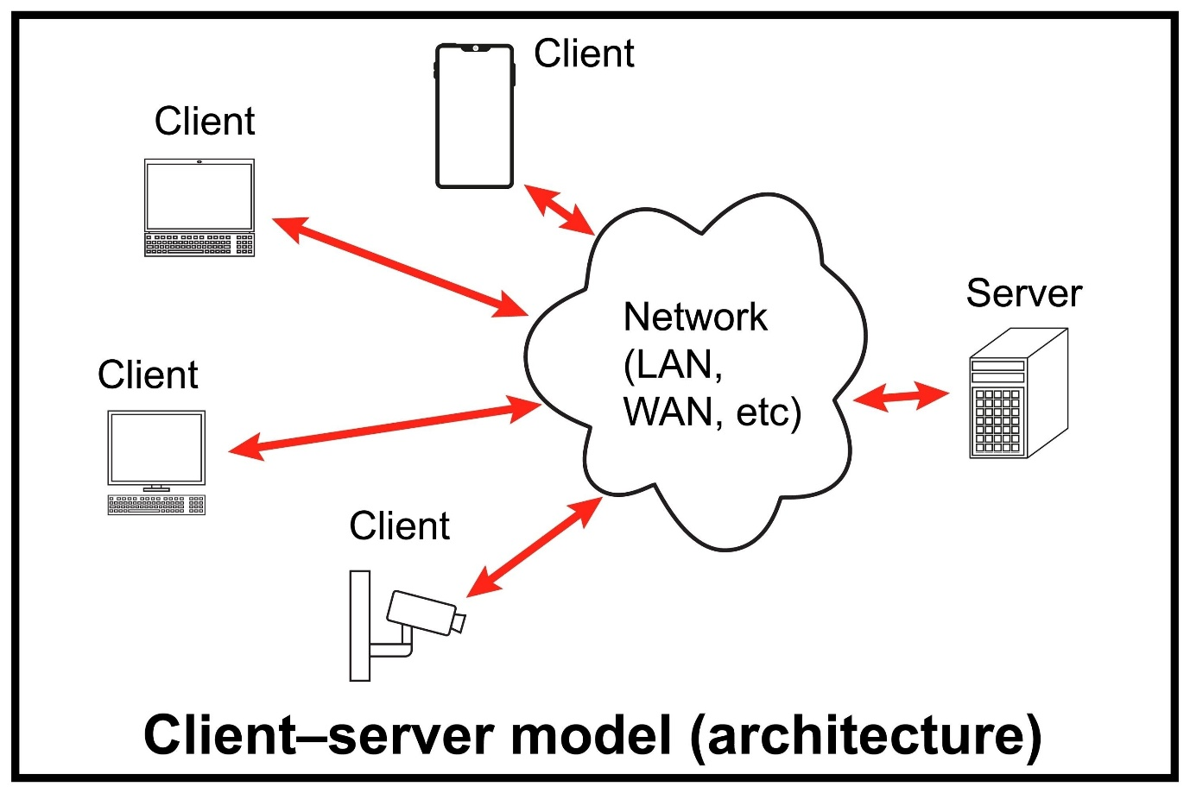
Shutterstock
- The Client (Frontend) handles user interaction, validation, and resource-intensive tasks like PDF generation.
- The Server (Backend) acts as a secure API gateway for communication and notification services.

4. Technical Stack
The project utilizes a modern, type-safe tech stack to ensure performance and reliability.
4.1. Frontend (User Interface)
- Framework: React.js (via Vite) – For a fast, reactive user interface.
- Language: TypeScript – For type safety and reducing runtime errors.
- Styling: Tailwind CSS & ShadCN UI – For a responsive, professional aesthetic.
- Form Handling: React Hook Form – For efficient state management.
- Validation: Zod – For strict schema validation of inputs (e.g., Aadhar, Marks).
- Core Engine: pdf-lib – For generating application PDFs client-side without server latency.
4.2. Backend (API & Services)
- Runtime: Node.js – For scalable, non-blocking server-side logic.
- Framework: Express.js – For defining RESTful API endpoints.
- Email Service: Nodemailer – For SMTP-based email transmission (Gmail Service).
- Middleware: Multer (File Handling) & CORS (Security).
4.3. Infrastructure & Tools
- Database (Optional/Future): Supabase (PostgreSQL).
- Version Control: Git & GitHub.
- Environment Management: Dotenv for securing API keys.

5. Key Modules
5.1. The Smart Admission Form
The interface allows students to input personal, academic, and contact details.
- Real-time Cutoff Calculation: As students enter their Physics, Chemistry, and Maths marks, the system auto-calculates their engineering cutoff ((P+C)/2 + M) and displays their eligibility status dynamically.
- Schema Validation: Prevents submission of invalid data (e.g., ensuring phone numbers are 10 digits, emails are valid).
5.2. Client-Side PDF Generation
Unlike traditional systems that generate PDFs on the server, this portal uses pdf-lib to generate the official application in the browser.
- Benefit: Reduces server CPU load and ensures user privacy.
- Output: A professionally formatted PDF containing the student's photo, details, and a calculated cutoff score.
5.3. Email Integration & Notification Protocol
This is the core communication backbone of the system.
Workflow:
- Payload Construction: The frontend packages the generated PDF + Metadata into FormData.
- Transmission: Data is sent via a secure POST request to the Node.js backend.
- Dual-Notification Logic: The backend generates two distinct emails:
  - Student Receipt (Blue Theme): A professional acknowledgment confirming submission, including date, time, and the application PDF.
  - Admin Alert (Red Theme): An "Action Required" report for the college admin, detailing the new applicant's data for quick verification.
- Security: The system uses Google App Passwords and Environment Variables (.env) to secure SMTP credentials, ensuring the primary email account remains protected.

6. Working Protocol (Detailed Flow)
Step | Actor | Action | System Response
1 | Student | Fills Admission Form & Uploads Docs | Frontend validates data in real-time.
2 | Student | Clicks "Submit" | Browser generates a PDF Blob locally.
3 | System | Backend API Call | Frontend sends PDF + Data to Node.js Server.
4 | Server | Processing | Server extracts PDF to Buffer, formats HTML templates.
5 | Server | Dispatch | Sends emails to Student (To) and Admin (CC/Separate).
6 | Student | Reception | Receives "Application Receipt" with PDF attached.
7 | Admin | Reception | Receives "New Application Alert" with PDF attached.

7. Future Upgrades & Scope
To ensure the SSMIET Admission Portal remains cutting-edge, the following upgrades are proposed for Phase 2 development:
- Payment Gateway Integration: Integration with Razorpay/Stripe to allow students to pay application fees directly within the portal.
- Admin Dashboard: A dedicated React-based Admin Panel to view, filter, and export student data (Excel/CSV) instead of just receiving emails.
- SMS Notifications: Integration with Twilio or Fast2SMS to send OTP verification and submission confirmation via SMS.
- AI-Based Analytics: Since this is a CSBS project, future versions can include an AI module to predict admission probability based on cutoff trends.

8. Conclusion
The SSMIET Admission Portal successfully bridges the gap between manual administration and digital efficiency. By leveraging modern web technologies like React, TypeScript, and Node.js, the project delivers a seamless experience for students while reducing the administrative burden on the institution. This project stands as a testament to the practical application of Computer Science and Business Systems principles in solving real-world educational challenges.

End of Documentation

